**Minor I**

**Year 2020-21**

**Semester – V**

**University of Petroleum and Energy Studies**

**Anirudh Singh Chauhan  
Ayush Shrivastava**

**Ayush Aryan**

**Image Processing**

**Mentor: Dr. Tanupriya, Associate Professor**

**Noise in Images**

Image noise is random variation of brightness or color information in images, and is usually an aspect of electronic noise.

Noise is undesired fluctuations of color or luminance that obscure detail in the shot you were trying to capture.

Image noise arises largely in underexposed footage as pixels that have light fluctuation to report in the intended image but are being over amplified by boosted ISO values. Beyond exposure, sensors are also susceptible to a range of other issues that create noise in the final image. The heat of the sensor or other outside interference can also cause noise.

**Cause of Noise**

Image noise can arise due to many factors. Some of the common cause of image noise are

1. Electricity levels
2. Heat levels
3. Sensor Illumination Levels
4. High ISO
5. Analog-to-digital conversion can generate error in some pixels
6. Natural inherent variation in photons striking each pixel at any time
7. Sensor readout is sampled or quantized
8. Due to natural or man-made signals interferes with the recorded signal

Image noise arises primarily in underexposed footage as pixels have little light fluctuation to report in the intended image but are being over-amplified by boosted ISO values. In low-light situations where the sensor is being over-volted (ISO being pushed), each pixel has very little light wave fluctuation to report before being amplified. When you see noise in these situations, you are actually seeing the affected pixels reporting the fluctuations of the voltage of the pixel’s amplifier over the sensor.

**What is the loss?**

Mathematically loss function or cost function maps an event or values of one or more variables into a real number intuitively representing some cost associated with the event.

Therefore, loss is the numerical analysis of amount of noise present in the image w.r.t the ideal image.

**Why reduce the noise**

Since noise are the unwanted element in the image, the advantaged of reducing image noise are

1. Less unwanted elements in image
2. Better image quality
3. Improved data for image processing machine learning or deep learning models

**Different types of noise**

Types of Image noise are: -

1. **Gaussian Noise:** It is also called as electronic noise because it arises in amplifiers or detectors. Gaussian noise caused by natural sources such as thermal vibration of atoms and discrete nature of radiation of warm objects. Principal sources of Gaussian noise in digital images arise during acquisition e.g. sensor noise caused by poor illumination and/or high temperature, and transmission e.g. electronic circuit noise. In digital image processing Gaussian noise can be reduced using a spatial filter, though when smoothing an image, an undesirable outcome may result in the blurring of fine-scaled image edges and details because they also correspond to blocked high frequencies.
2. **Salt and Pepper Noise (Impulsed Valued Noise):** This is also called data drop noise because statistically its drop the original data values. This noise is also referred as salt and pepper noise. However, the image is not fully corrupted by salt and pepper noise instead of some pixel values are changed in the image. Although in noisy image, there is a possibility of some neighbors does not changed.

Salt and Pepper noise generally corrupted the digital image by malfunctioning of pixel elements in camera sensors, faulty memory space in storage, errors in digitization process and many more

1. **Speckle Noise:** This noise is multiplicative noise. Their appearance is seen in coherent imaging system such as laser, radar and acoustics etc.. Speckle noise can exist similar in an image as Gaussian noise
2. **White Noise:** Noise is essentially identified by the noise power. Noise power spectrum is constant in white noise. This noise power is equivalent to power spectral density function. The statement “Gaussian noise is often white noise” is incorrect
3. **Brownian Noise:** Colored noise has many names such as Brownian noise or pink noise or flicker noise or 1/f noise. In Brownian noise, power spectral density is proportional to square of frequency over an octave i.e., its power falls on 1⁄4 th part.

Brownian noise caused by Brownian motion. Brownian motion seen due to the random movement of suspended particles in fluid. Brownian noise can also be generated from white noise

1. **Periodic Noise:** This noise is generated from electronics interferences, especially in power signal during image acquisition. This noise has special characteristics like spatially dependent and sinusoidal in nature at multiples of specific frequency. It’s appears in form of conjugate spots in frequency domain. It can be conveniently removed by using a narrow band reject filter or notch filter.
2. **Quantization Noise:** Quantization noise appearance is inherent in amplitude quantization process. It is generally presents due to analog data converted into digital data.
3. **Photon Noise:** The appearance of this noise is seen due to the statistical nature of electromagnetic waves such as x-rays, visible lights and gamma rays. The x-ray and gamma ray sources emitted number of photons per unit time
4. **Structured Noise:** Structured noise are periodic, stationary or non stationary and aperiodic in nature. If this noise is stationary, it has fixed amplitude, frequency and phase. Structured noise caused by interferences among electronic components
5. **Gamma Noise:** Gamma noise is generally seen in the laser based images. It obeys the Gamma distribution.
6. **Rayleigh Noise:** Rayleigh noise presents in radar range images

**Our Objective:**

To remove Gaussian Noise from the image and return low noise image as output with the help of Gaussian filter.

**Explain Gaussian:**

Gaussian noise, named after Carl Friedrich Gauss, is statistical noise having a probability density function (PDF) equal to that of the normal distribution, which is also known as the Gaussian distribution. In other words, the values that the noise can take on are Gaussian-distributed.

The probability density function “p” of a Gaussian random variable “z” is given by:

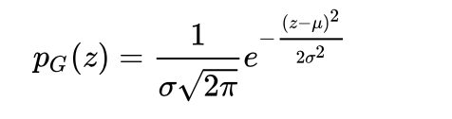

Principal sources of Gaussian noise in digital images arise during acquisition e.g. sensor noise caused by poor illumination and/or high temperature, and/or transmission e.g. electronic circuit noise.

In digital image processing Gaussian noise can be reduced using a spatial filter, though when smoothing an image, an undesirable outcome may result in the blurring of fine-scaled image edges and details because they also correspond to blocked high frequencies.

**Solution of Gaussian:**

A Gaussian filter is a linear filter. It's usually used to blur the image or to reduce noise. If you use two of them and subtract, you can use them for "unsharp masking" (edge detection). The Gaussian filter alone will blur edges and reduce contrast.

In image processing, a Gaussian blur (also known as Gaussian smoothing) is the result of blurring an image by a Gaussian function (named after mathematician and scientist Carl Friedrich Gauss). It is a widely used effect in graphics software, typically to reduce image noise and reduce detail. The visual effect of this blurring technique is a smooth blur resembling that of viewing the image through a translucent screen.

Gaussian smoothing is also used as a pre-processing stage in computer vision algorithms in order to enhance image structures at different scales—see scale space representation and scale space implementation.

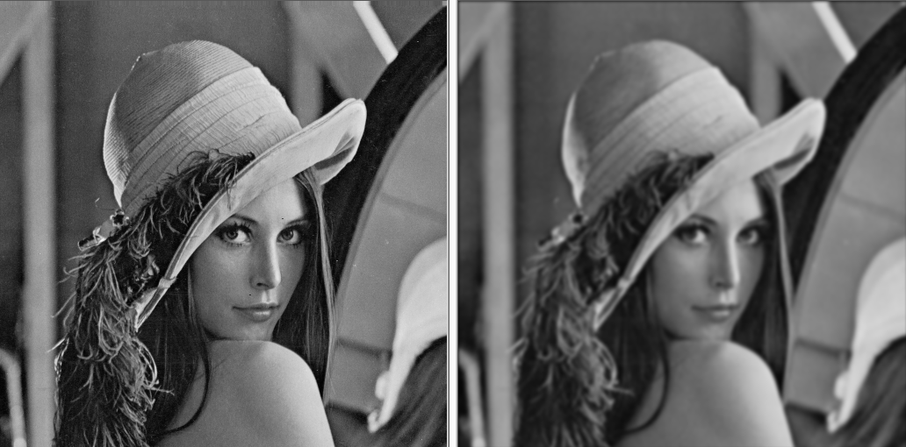

**Solution of Gaussian:**